

**ONLINE COURSE RESERVATION SYSTEM**

**A PROJECT REPORT**

***Submitted by***

**K.DIVYA (920417104013)**

***in partial fulfillment for the award of the degree***

***of***

**BACHELOR OF ENGINEERING**

**IN**

**COMPUTER SCIENCE AND ENGINEERING**

**KAMARAJ COLLEGE OF ENGINEERING AND TECHNOLOGY**

**MADURAI-625701**

**ANNA UNIVERSITY: CHENNAI 600 025**

**APRIL2020**

**TABLE OF CONTENTS**

|  |  |  |
| --- | --- | --- |
| **ChapterNo** | **Title** | **PageNo** |
| **1** | **INTRODUCTION** |  |
| **2** | **SYSTEM REQUIREMENTS** |  |
| **3** | **SYSTEM DESIGN** |  |
| **4** | **SYSTEM IMPLEMENTATION** |  |
| **5** | **CONCLUSION** |  |
| **6** | **APPENDIX** |  |
| **7** | **REFERRENCES** |  |

**1.INTRODUCTION**

Online Course Reservation System is an interface between the User, Professor and the Administrator responsible for the Course.

## Purpose

###### The purpose of this Online Course Reservation System is to describe the course reservation system which provides the course details, registration, learning and submit the assignment on various types of reservation namely.

* View the Course Details
* Registration
* Learn the Course using Lecture Videos
* Submit the Assignment

## Document Conventions

This Document was created based on the IEEE template for System Requirement Specification Documents.

## Intended Audience and Reading Suggestions

* Typical Users, such as students, who want to apply online course for reservation system (Social networks, Social Media networks, Semantic networks etc.)
* Advanced/Professional Users, such as engineers or researchers, who want to apply online course reservation system.
* Users, students who are interested in studying on the course by further developing it.

## Product Scope

* The System provides an online interface to the user where they can fill in their personal details and submit the necessary documents (may be by scanning).
* Provide a communication platform between the User and the Administrator.

## References

IEEE Software Requirement Specification format.

[www.vidyarthiplus.com](http://www.vidyarthiplus.com)

**2.SYSTEM REQUIREMENTS**

**2.1 SOFTWARE REQUIREMENTS**

**FRONT END: HTML,,CSS,PHP**

**BACK END: MYSQL**

* 1. **HARDWARE REQUIREMENTS**

**PROCESSOR:** AMD PRO

**RAM: 4.00** GB (2.98 GB usable)

**SYSTEM TYPE: 32-** bit operating system , **x64**- based processor

**3.SYSTEM DESIGN**

**3.1 CLASS DIAGRAM**

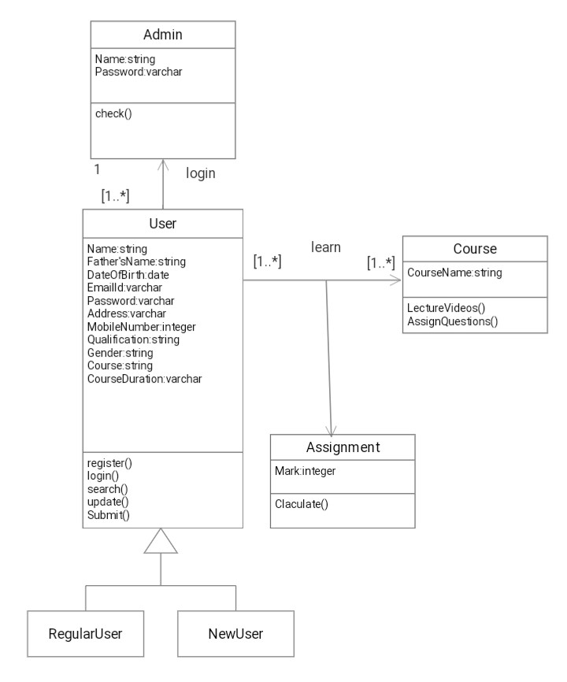

**3.2 TABLES**

**Table Name: register**

|  |  |  |  |  |  |
| --- | --- | --- | --- | --- | --- |
| **Name** | **FatherName** | **DateOfBirth** | **EmailId** | **Password** | **Address** |
| K.DIVYA | R.KUMAR | 2000-06-07 | divya@gmail.com | Rajeswari | virudhunagar |
| K.KAVi | S.KUMAR | 2000-02-13 | kavi@gmail.com | kdvk | sivakashi |
| R.RAMYA | R.RAM | 2000-08-07 | ramya@gmail.com | Lakshmi | virudhunagar |

|  |  |  |  |  |
| --- | --- | --- | --- | --- |
| **MobileNumber** | **Qualification** | **Gender** | **Course** | **CourseDuration** |
| 8090304037 | B.E | Female | Python | Six weeks |
| 7890654332 | B.E | Male | Java | Eight weeks |
| 7890654321 | B.E | Female | c++ | Four weeks |

**Table Name: assignment**

|  |  |  |  |  |  |  |
| --- | --- | --- | --- | --- | --- | --- |
| **Name** | **q1** | **q2** | **q3** | **q4** | **q5** | **Mark** |
| K.DIVYA | a | c | c | a | b | 5 |
| K.KAVI | a | c | c | a | b | 5 |
| R.RAMYA | a | c | c | a | b | 5 |

**4.SYSTEM IMPLEMENTATION**

**4.1 LIST OF MODULES**

1. Authentication module
2. Maintainance module
3. Report Generation module
   1. **Module Explanation**

**1.Authentication module**

Authentication module is used by students to login in with their username and password to know the details of courses borrowed by them

**2.Maintainance module**

* **Insert:**

Insert module is used to add the information of student or user borrowed such as Name,FatherName,DateOfBirth,EmailId,Password,Address,MobileNumber,Qualification,Gender,Course,CourseDuration etc.

* **Update:**

Update module is used to update the any details of student information.

**3.Report Generation module**

* **View:**

Display module is used to display the database of Student information and Assignment marks.

* 1. **SCREEN SHOT**

**DATABASE OF OCRS**

**Register table**

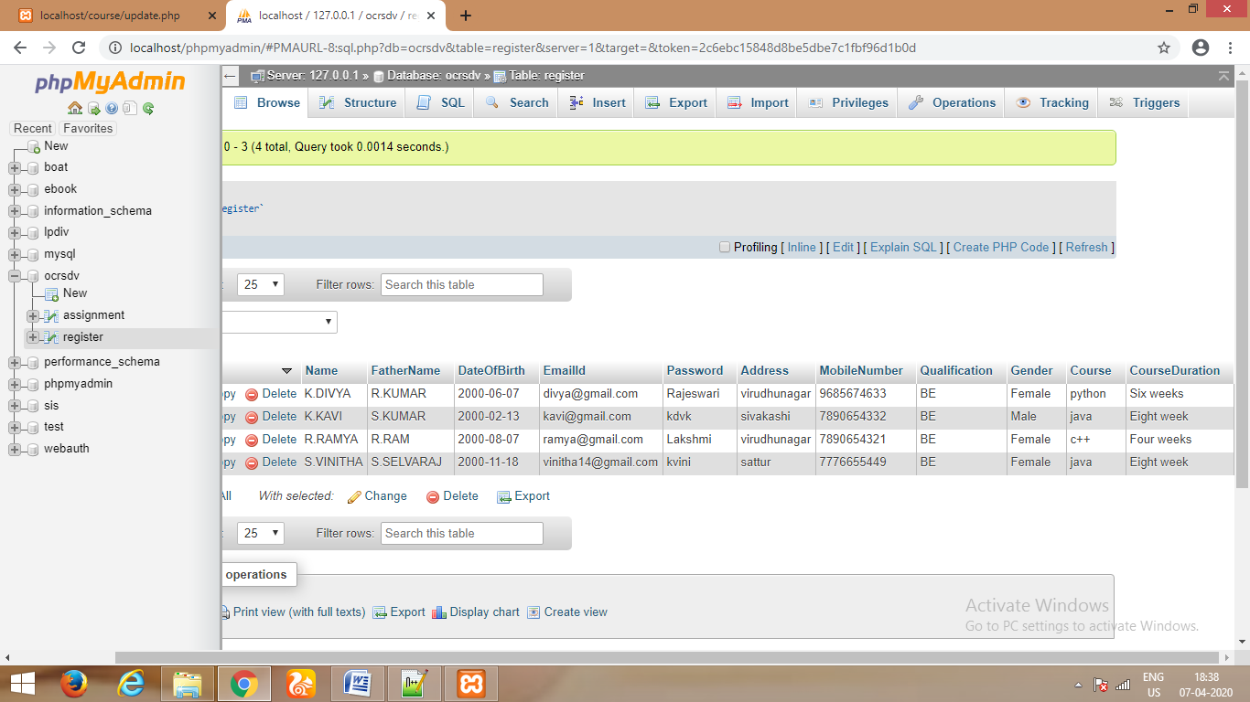

**Assignment table**

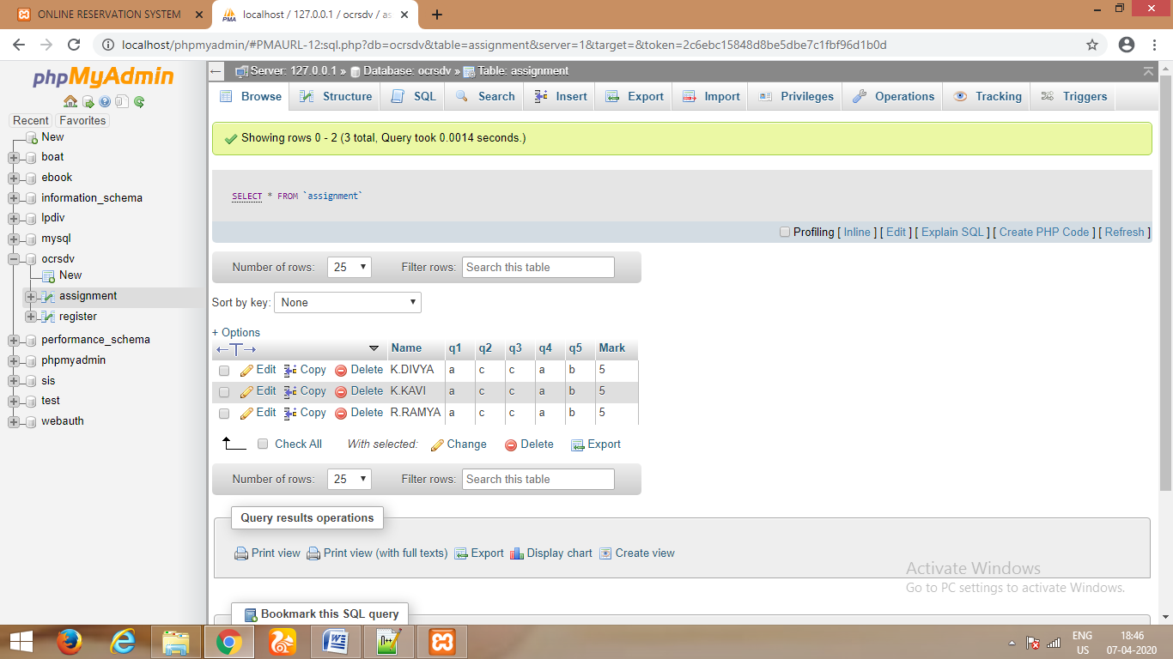

**OUTPUT**

**SCREEN SHOTS**

**WELCOME FORM**

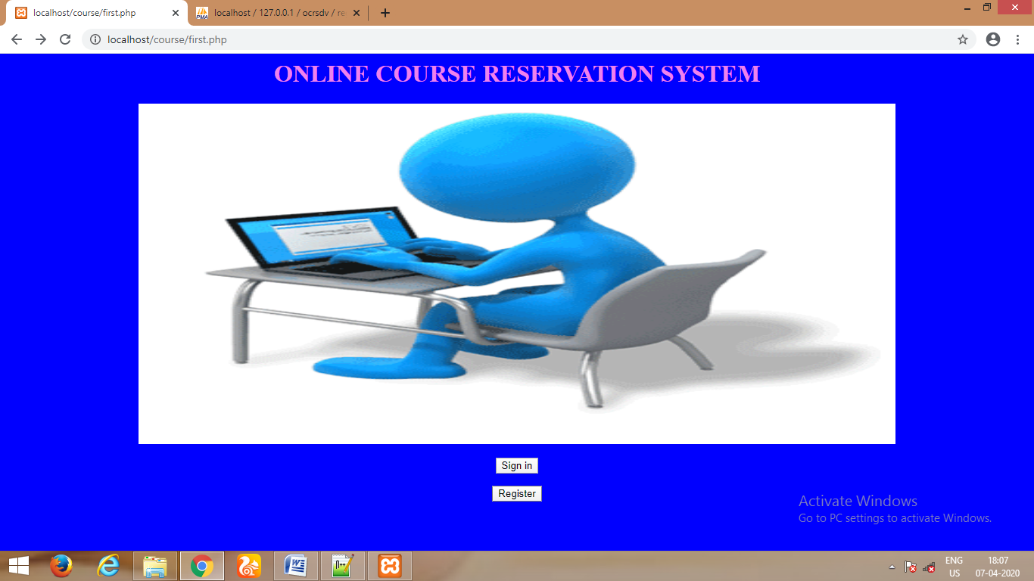

**SIGNUP PAGE (REGISTRATION)**

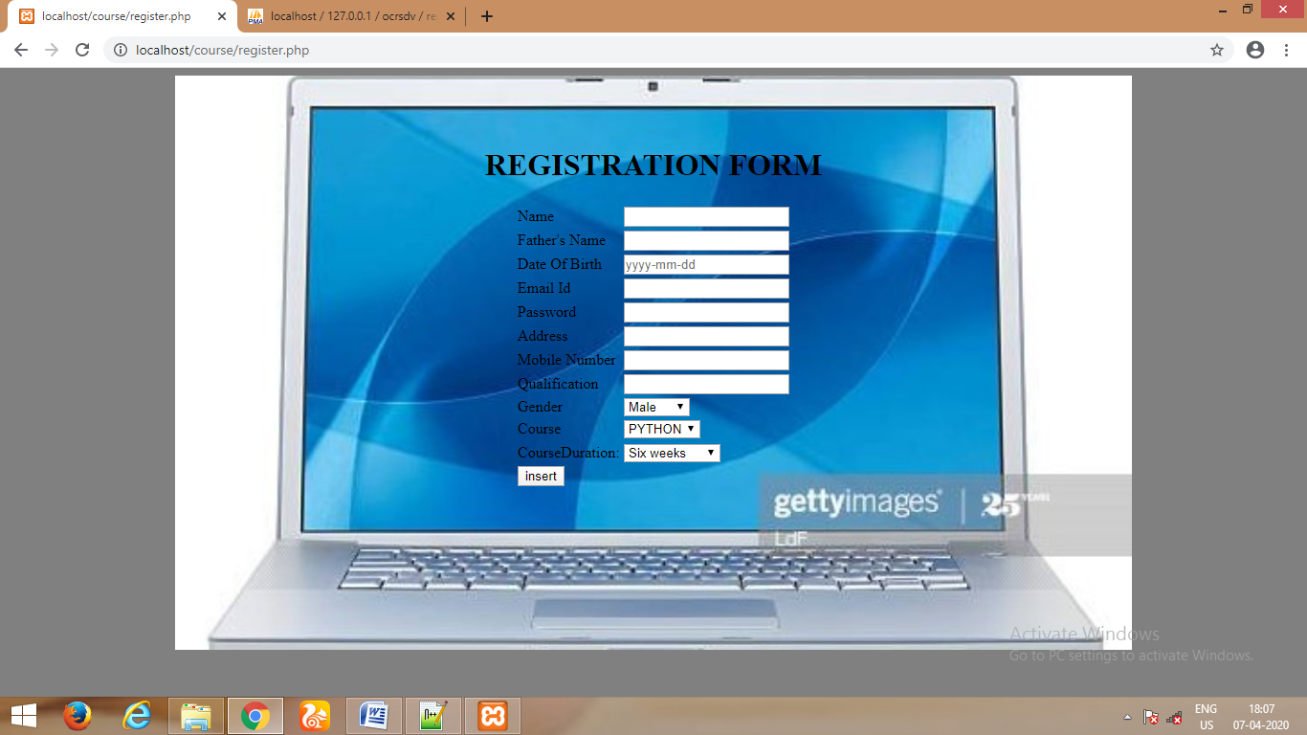

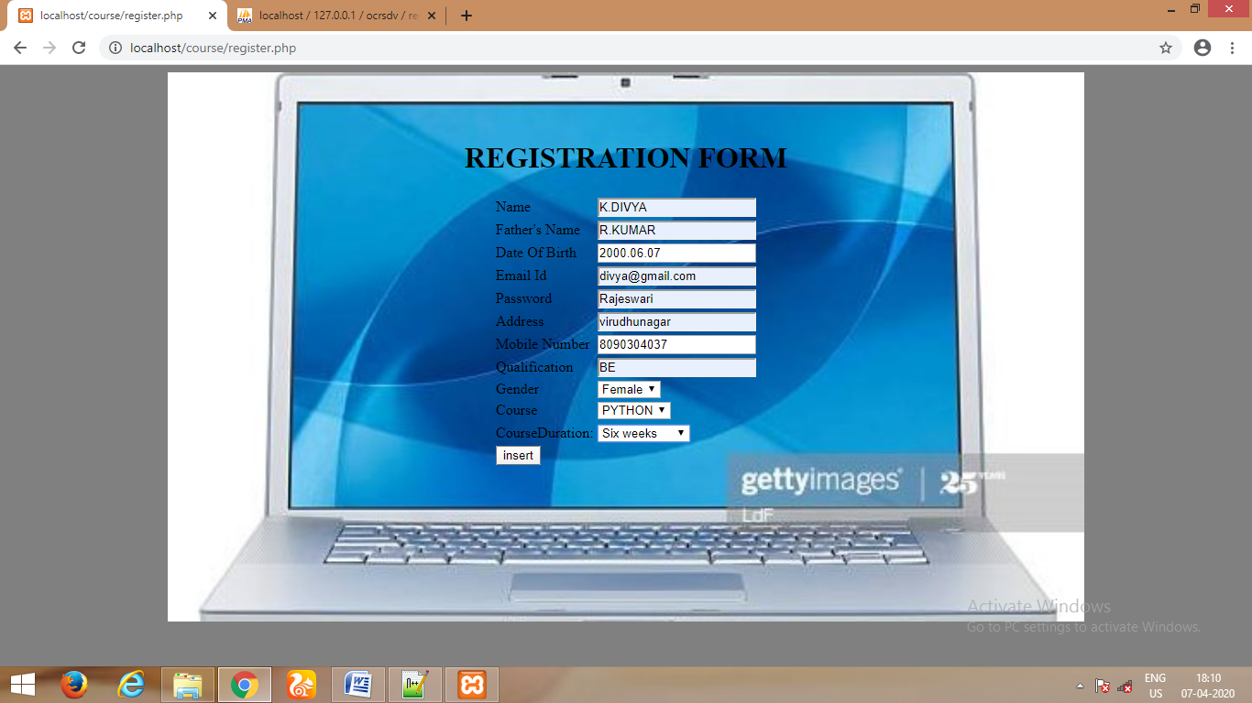

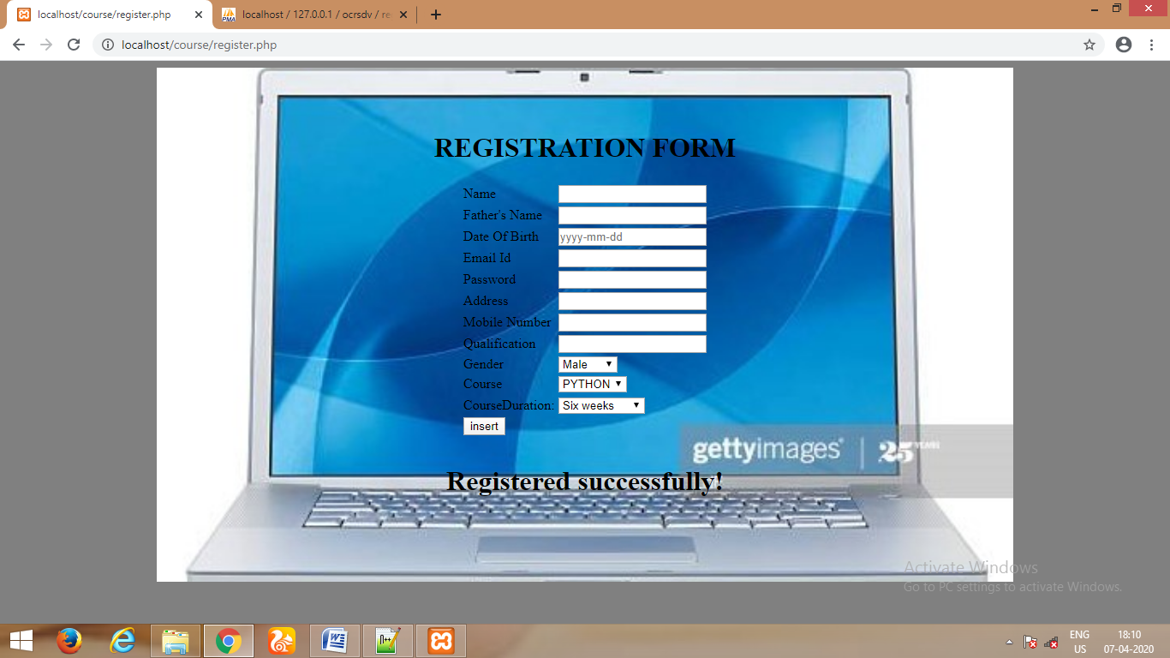

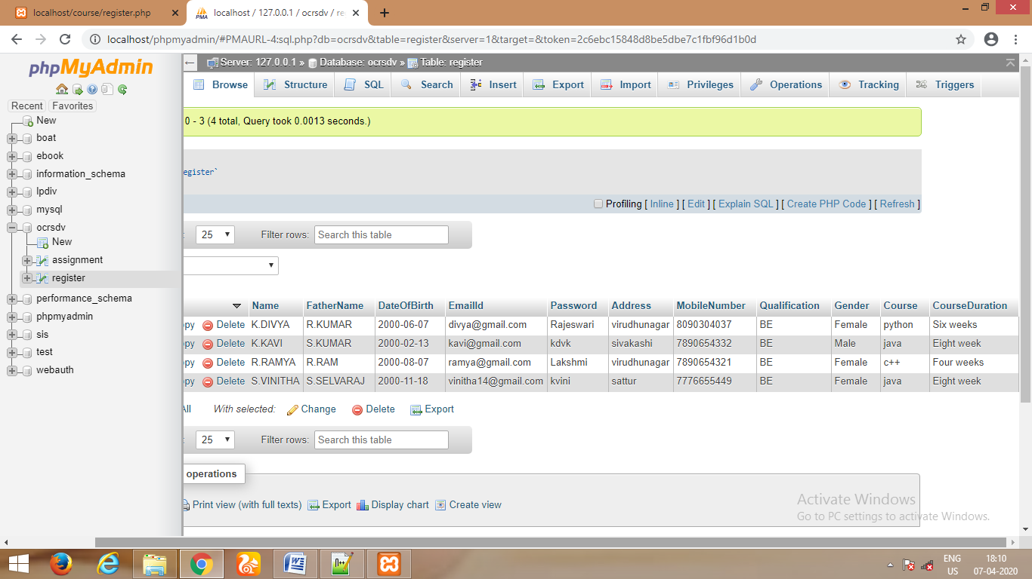

**LOGIN PAGE**

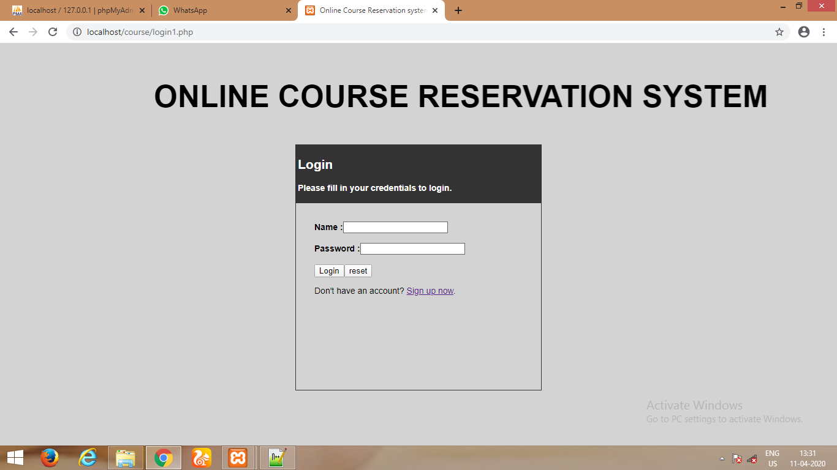

**The user name or password are incorrect**

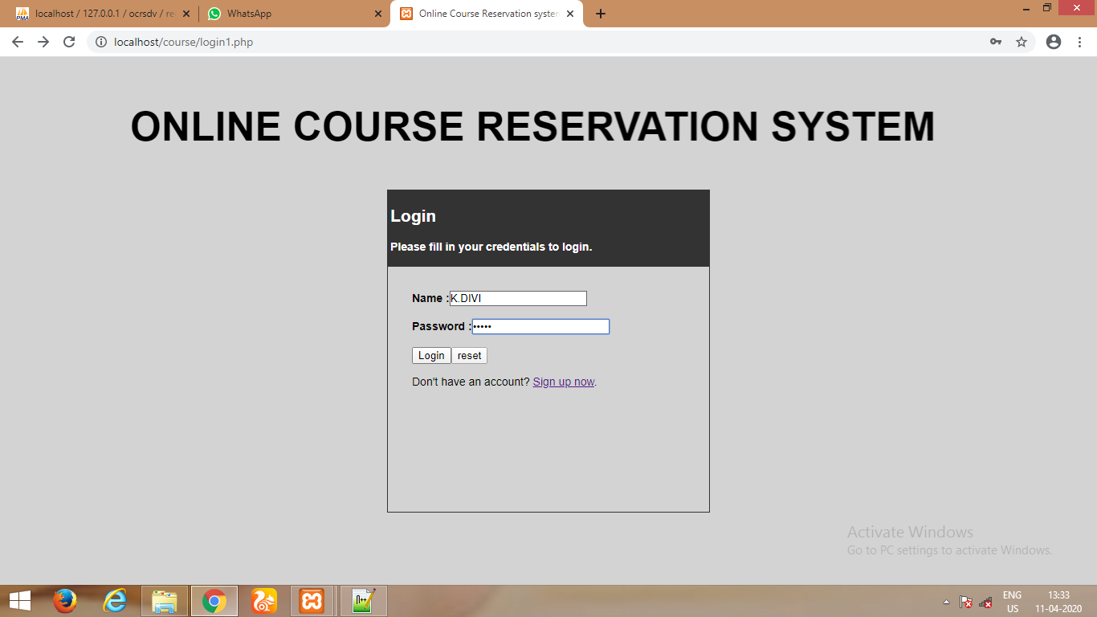

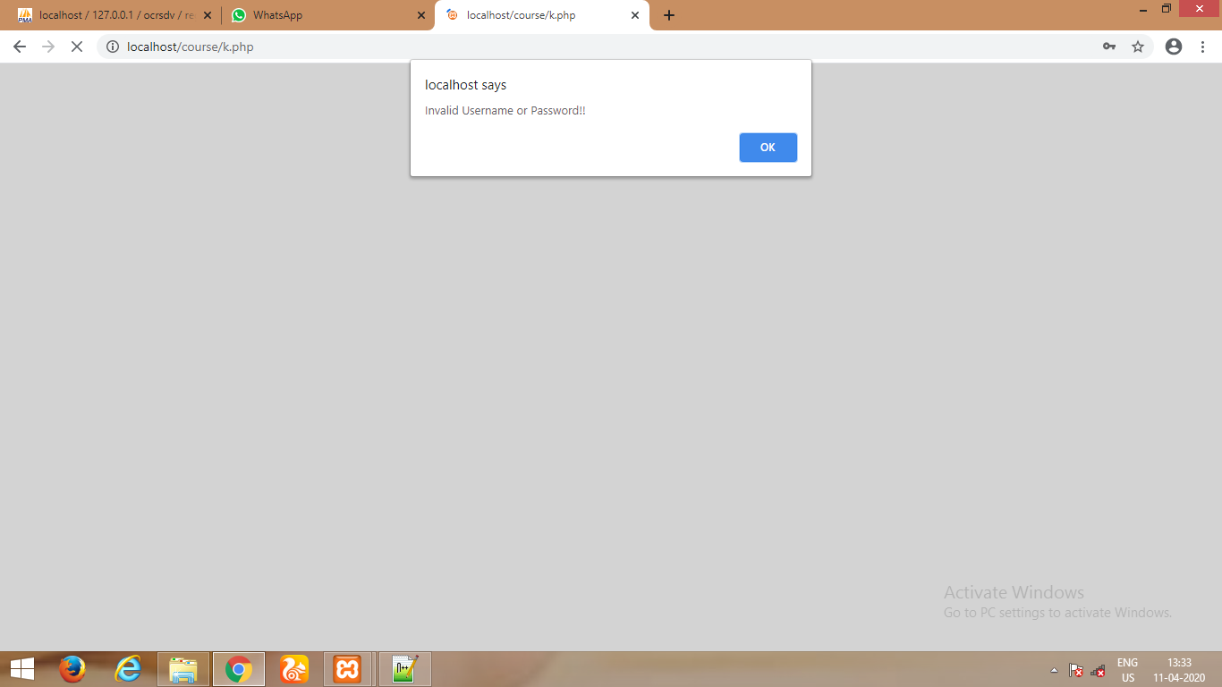

**The username or password are correct**

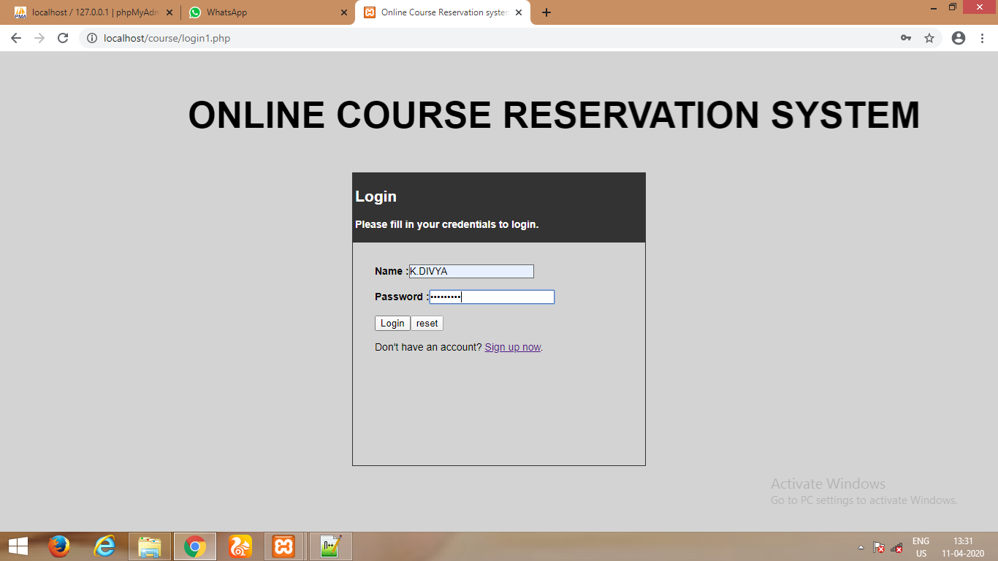

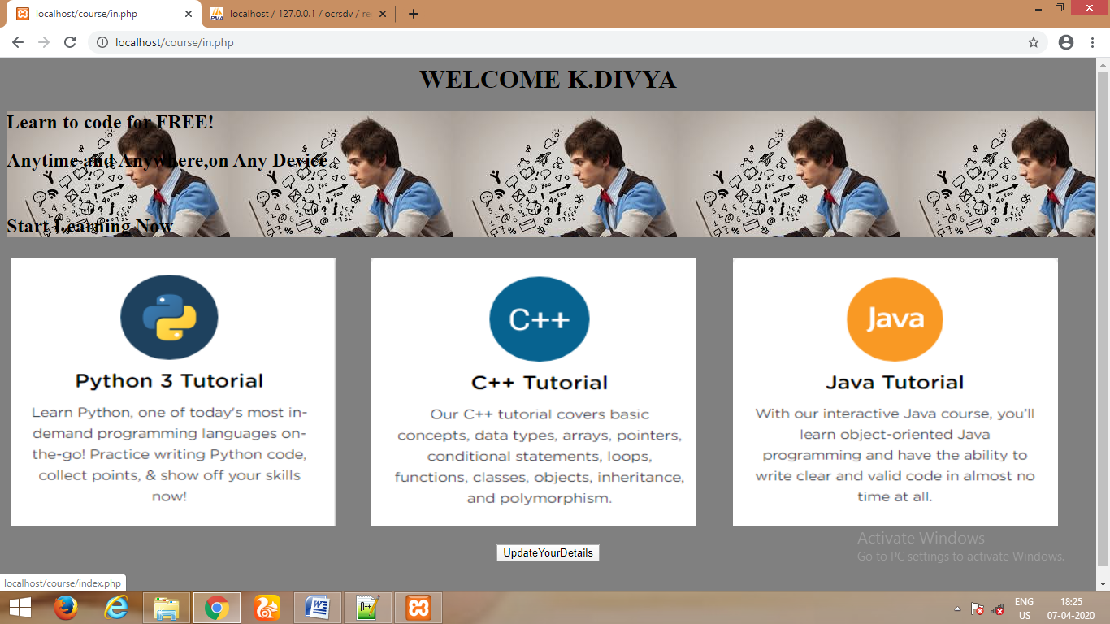

**UPDATE (Click the UpdateYourDetails Button)**

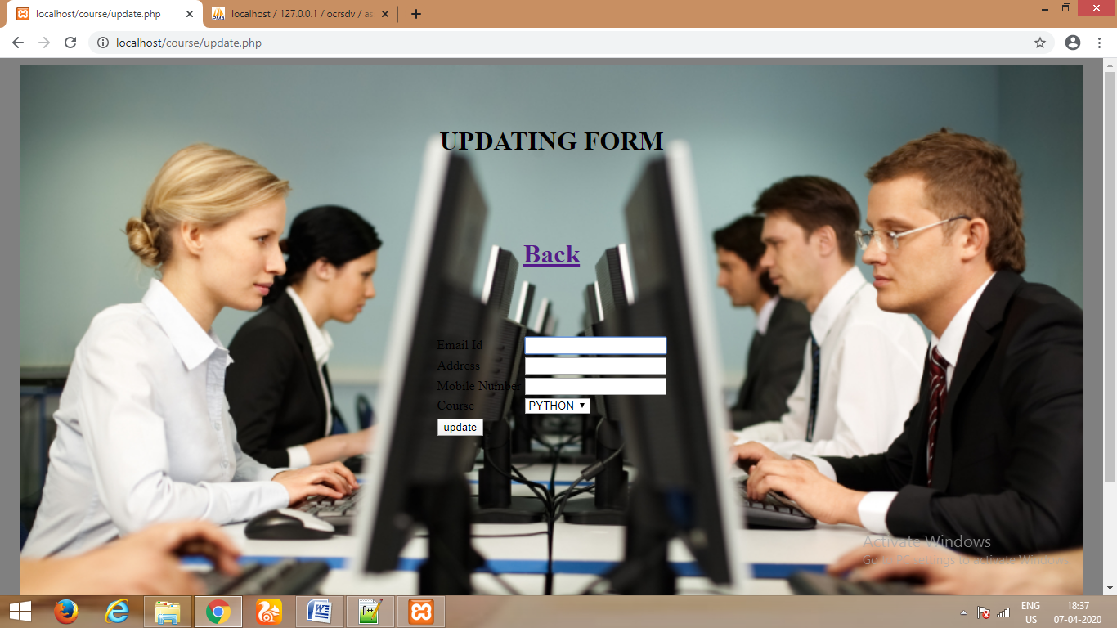

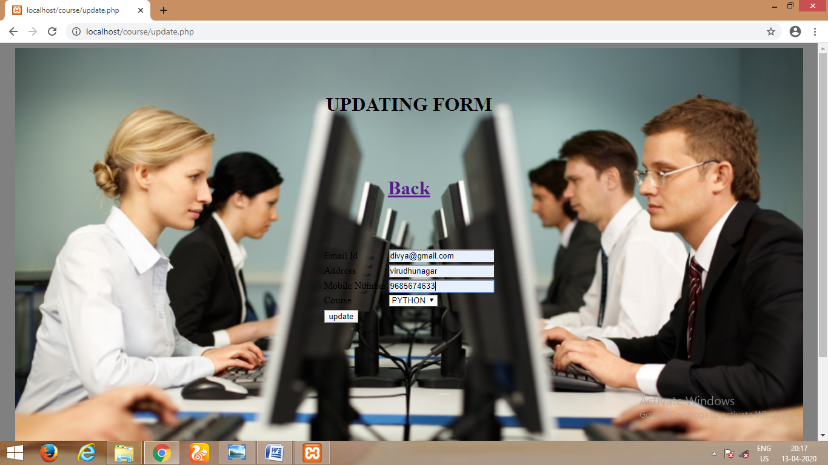

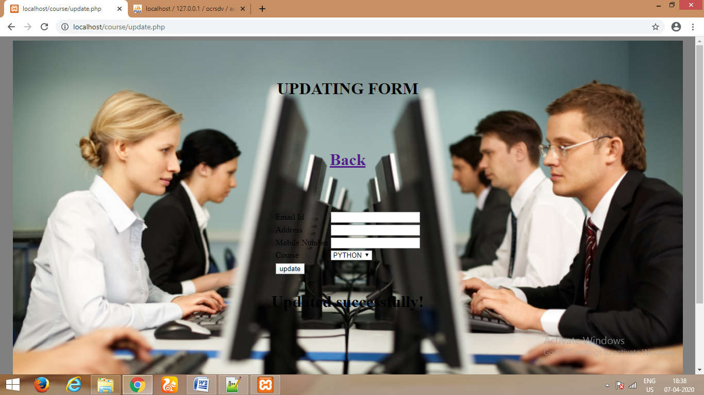



**Click the course image(K.DIVYA registered the course is python)**

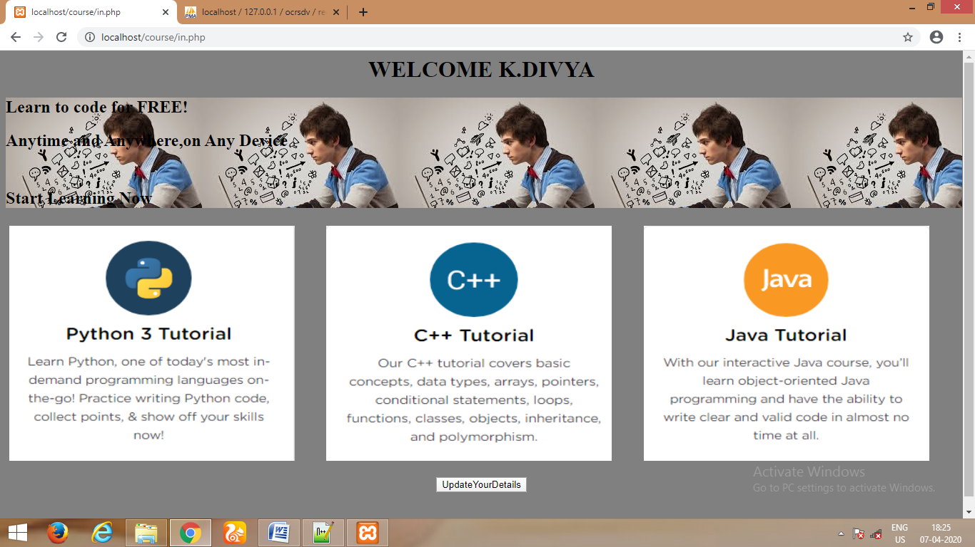



**LECTURE VIDEOS**

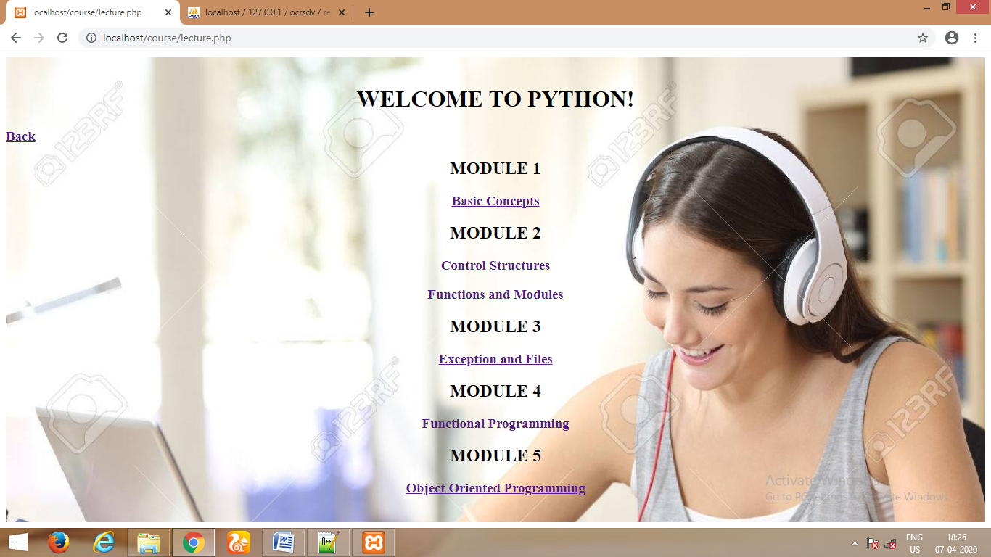

**Click the link**

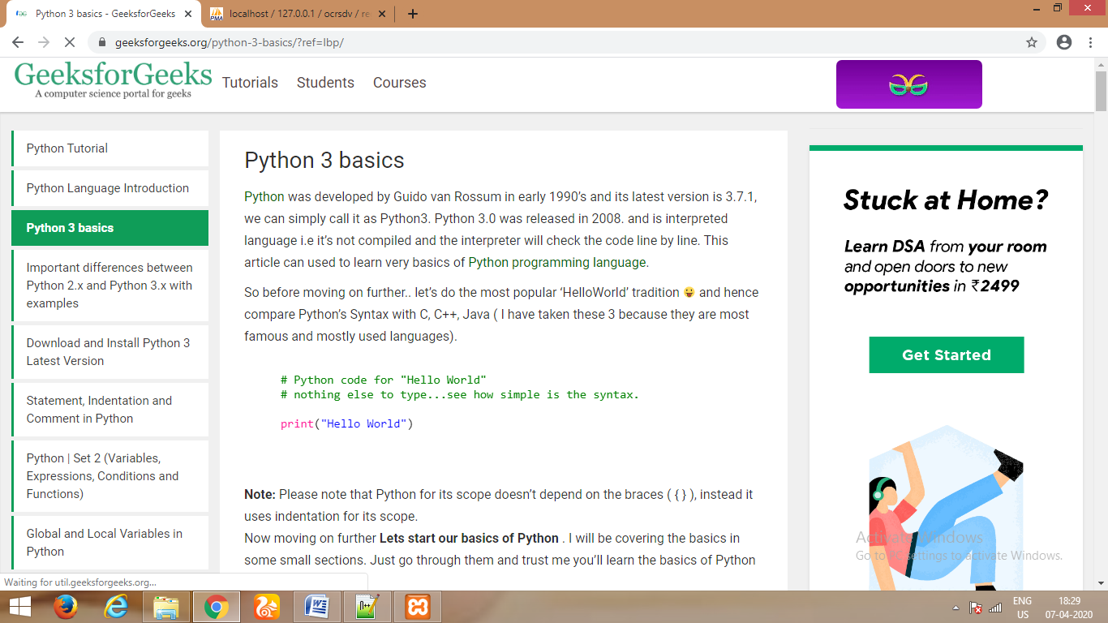

**ASSIGNMENT**



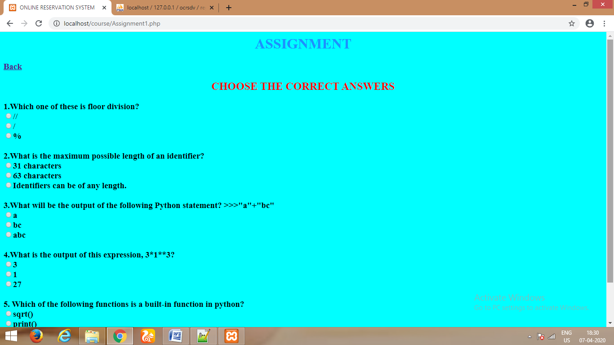

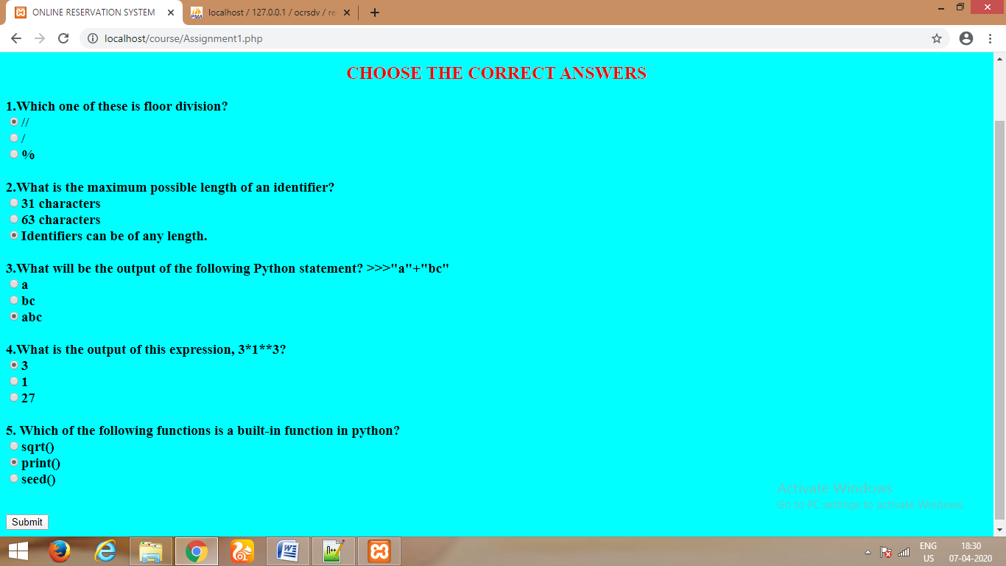

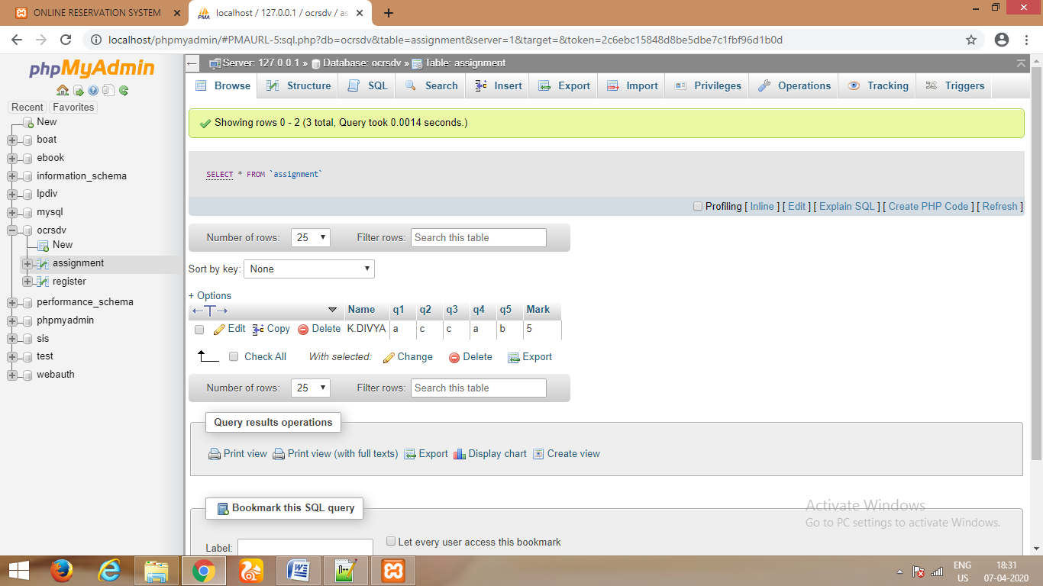

**PROGRSS REPORT**



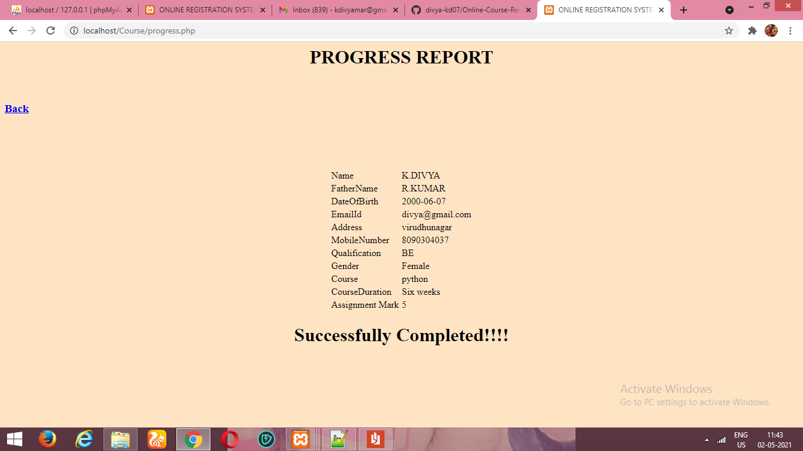

**CERTIFICATE**



**SIGNOUT**





**5.CONCLUSION**

Thus the mini project for Online Course Reservation System has been executed successfully and codes are generated.

Our system is password protected and it only allows authorized user to access various function available in the system.

**A.APPENDIX**

**A.1 CODING:**

**WELCOME PAGE(first.php)**

<html>

<head>

<style>

h1 {

color: violet;

}

</style>

</head>

<body bgcolor="blue"><center>

<h1>ONLINE COURSE RESERVATION SYSTEM</h1>

<img src="firr.gif" width=1000 height=450><br><br>

<form action="login1.php" method="POST">

<button>Sign in</button>

</form>

<form action="register.php" method="POST">

<button>Register</button>

</form>

</center>

</body>

<html>

**SIGNIN PAGE(register.php)**

<html>

<?php $conn = mysqli_connect("localhost","root","","ocrsdv") or die ("connection failed");?>

<head>

<style>

.bgimg{

background-image:url('reg.jpg');

background-size:cover;

height:600;

width:1000;

}</style>

</head><center>

<body bgcolor="grey">

<div class="bgimg">

</style><br><br><br>

<center><h1>REGISTRATION FORM<h1><center>

<form method="post">

<table>

<tr><td>Name</td><td><input type="text" name="n" required></td></tr>

<tr><td>Father's Name</td><td><input type="text" name="n1" required></td></tr>

<tr><td>Date Of Birth</td><td><input type="varchar" name="dob" placeholder="yyyy-mm-dd"></td></tr>

<tr><td>Email Id</td><td><input type="text" name="e" required></td></tr>

<tr><td>Password</td><td><input type="varchar" name="pwd" required></td></tr>

<tr><td>Address</td><td><input type="varchar" name="add"></td></tr>

<tr><td>Mobile Number</td><td><input type="varchar" name="ph"></td></tr>

<tr><td>Qualification</td><td><input type="text" name="qua"></td></tr>

<tr><td>Gender</td><td> <select name="Gender">

<option value="Male">Male</option>

<option value="Female">Female</option>

<option value="Others">Others</option>

</select></td></tr>

<tr><td>Course</td><td> <select name="Course">

<option value="python">PYTHON</option>

<option value="c++">C++</option>

<option value="java">JAVA</option>

</select></td><tr>

<tr><td>CourseDuration:</td><td><select name="c1">

<option value="Six weeks">Six weeks</option>

<option value="Eight weeks">Eight weeks</option>

<option value="Four weeks">Four weeks</option>

<option value="Three weeks">Three weeks</option></td></tr>

<tr><td><input type="submit" name="i" value="insert"><td></tr>

</table>

</form>

</center>

</body>

<?php

if(isset($_POST["i"]))

{

$Name=$_POST["n"];

$FatherName=$_POST["n1"];

$DateOfBirth=$_POST["dob"];

$EmailId=$_POST["e"];

$Password=$_POST["pwd"];

$Address=$_POST["add"];

$MobileNumber=$_POST["ph"];

$Qualification=$_POST["qua"];

$Gender=$_POST["Gender"];

$CourseDuration=$_POST["c1"];

$Course=$_POST["Course"];

mysqli_query($conn,"insert into register values ('$Name','$FatherName','$DateOfBirth','$EmailId','$Password','$Address','$MobileNumber','$Qualification','$Gender','$Course','$CourseDuration')") or die ("could not enter");

echo "Registered successfully!";

}

?>

</div>

</html>

**LOGIN PAGE(login1.php)**

<html>

<head>

<title>Online Course Reservation system </title>

<style type = "text/css">

body {

font-family:Arial, Helvetica, sans-serif;

font-size:14px;

}

.head{

font-weight:bold;

font-size:25px;

text-align:center;

}

label {

font-weight:bold;

width:100px;

font-size:14px;

}

.box {

border:#666666 solid 1px;

}

h1 {

color: blank;

}

</style>

</head>

<body bgcolor="LightGray"><br>

<div class="head"><h1><marquee>ONLINE COURSE RESERVATION SYSTEM</marquee></h1></div><br>

<div align = "center">

<div style = "width:400px;height:400px; border: solid 1px #333333; " align = "left">

<div style = "background-color:#333333; color:#FFFFFF; padding:3px;">

<b><h2>Login</h2><p>Please fill in your credentials to login.</p></b></div>

<div style = "margin:30px">

<form method = "post" action="k.php">

<label>Name :</label><input type = "text" name = "n" class = "box" required /><br /><br />

<label>Password :</label><input type = "password" name = "pwd" class = "box" required /><br/><br />

<input type = "submit" value = "Login"/><input type="reset" value="reset"/>

<p>Don't have an account? <a href="register.php">Sign up now</a>.</p>

<!--<button type="submit" formaction="index.php">Sign In</button>-->

</form>

<div style = "font-size:11px; color:#cc0000; margin-top:10px"></div>

</div>

</div>

</div>

</body>

</html>

**k.php**

<?php

session_start();

$db = mysqli_connect('localhost','root','','ocrsdv');

if($_SERVER["REQUEST_METHOD"] == "POST") {

$Name =$_POST['n'];

$Password =$_POST['pwd'];

$sql = "SELECT Name,Password FROM register WHERE Name= '$Name' and Password= '$Password'";

$result = mysqli_query($db,$sql);

if($result){

$row = mysqli_fetch_array($result,MYSQLI_ASSOC);

$count = mysqli_num_rows($result);

if($count == 1) {

$_SESSION['name'] = $Name;

echo "<script>window.open('in.php','_self');</script>";

}else {

echo "<script>alert('Invalid Username or Password!!');</script>";

echo "<script>window.open('login1.php','_self');</script>";

}

}

else{

echo mysqli_error($db);

}

}

?>

**COURSE PAGE(in.php**)

<?php

session_start();

echo "<h1> <center>WELCOME ".$_SESSION['name']."</center></h1>";

?>

<!DOCTYPE html>

<html>

<head>

<style>

.bgimg{

background-image:url('cpj.jpg');

width:1340px;

}

* {

box-sizing: border-box;

}

.column {

float: left;

width: 33.33%;

padding: 5px;

}

/* Clearfix (clear floats) */

.row::after {

content: "";

clear: both;

display: table;

}

</style>

</head>

<body bgcolor="gray">

<div class="bgimg">

<h2>Learn to code for FREE!</h2>

<h2>Anytime and Anywhere,on Any Device<br><br><br>Start Learning Now</h1>

</div>

<div class="row">

<div class="column">

<a href="index.php">

<img src="py.png" alt="python" width="400" height="330"></a>

</div>

<div class="column">

<a href="index2.php">

<img src="c++.png" alt="C++" width="400" height="330"></a>

</div>

<div class="column">

<a href="index3.php">

<img src="java.png" alt="Java" width="400" height="330"></a>

</div>

</div><br>

<form action="update.php" method="POST"><center>

<button>UpdateYourDetails</button><br><br><br></center>

</form>

</body>

</html>

**UPDATEYOURDETAILS(update.php)**

<html>

<?php $conn = mysqli_connect("localhost","root","","ocrsdv") or die ("connection failed");?>

<head>

<style>

.bgimg{

background-image:url('f5.jpg');

background-size:cover;

height:800;

width:1300;

}

</style>

</head><center>

<body bgcolor="grey">

<div class="bgimg">

</style><br><br><br>

<center><h1>UPDATING FORM<h1><center>

<br><a href="http://localhost/course/in.php"><h4>Back</h4></a><br>

<form method="post">

<table>

<tr><td>Email Id</td><td><input type="text" name="e" required></td></tr>

<tr><td>Address</td><td><input type="varchar" name="add"></td></tr>

<tr><td>Mobile Number</td><td><input type="varchar" name="ph"></td></tr>

<tr><td>Course</td><td> <select name="Course">

<option value="python">PYTHON</option>

<option value="c++">C++</option>

<option value="java">JAVA</option>

</select></td><tr>

<tr><td><input type="submit" name="i" value="update"><td></tr>

</table>

</form>

</center>

</body>

<?php

if(isset($_POST["i"]))

{

$EmailId=$_POST["e"];

$Address=$_POST["add"];

$MobileNumber=$_POST["ph"];

$Course=$_POST["Course"];

mysqli_query($conn,"UPDATE register SET Address='$Address',MobileNumber='$MobileNumber',Course='$Course' WHERE EmailId='$EmailId'") or die ("could not enter");

echo "Updated successfully!";

}

?>

</div>

</html>

**PYTHON(index.php)**

<html>

<head>

<style>

.bgimg{

background-image:url('f3.jpg');

background-size:cover;

height:650;

width:1400;

}</style></head>

<div class="bgimg"><br>

<h1><center>PYTHON</h1></center>

<body bgcolor="grey">

<form action="lecture.php" method="POST">

<button>Lecture Videos</button><br><br><br>

</form>

<form action="Assignment1.php" method="POST">

<button>Assignments</button><br><br><br>

</form>

<form action="progress.php" method="POST">

<button>Progress</button><br><br><br>

</form>

<form action="login1.php" method="POST">

<button>SignOut</button><br><br><br>

</form>

</div>

</body>

</html>

**LECTURE VIDEOS(lecture.php)**

<!DOCTYPE html>

<html>

<head>

<style>

.bgimg{

background-image:url('lec.jpg');

background-size:cover;

}</style>

</head>

<body>

<div class="bgimg">

<br>

<center><h1>WELCOME TO PYTHON!</h1></center><a href="http://localhost/course/index.php"><h3>Back</h3></a><center>

<h2>MODULE 1</h2>

<p><a href="https://www.geeksforgeeks.org/python-3-basics/?ref=lbp/"><h3>Basic Concepts</h3></a></p>

<h2>MODULE 2</h2>

<p><a href="https://www.geeksforgeeks.org/loops-and-loop-control-statements-continue-break-and-pass-in-python/"><h3>Control Structures</h3></a></p>

<p><a href="https://www.w3schools.com/python/python_modules.asp"><h3>Functions and Modules</h3></a></p>

<h2>MODULE 3</h2>

<p><a href="https://www.geeksforgeeks.org/python-set-5-exception-handling/"><h3>Exception and Files</h3></a></p>

<h2>MODULE 4</h2>

<p><a href="https://kite.com/blog/python/functional-programming/"><h3>Functional Programming</h3></a></p>

<h2>MODULE 5</h2>

<p><a href="https://www.geeksforgeeks.org/object-oriented-programming-in-python-set-1-class-and-its-members/"><h3>Object Oriented Programming</h3></a></p></center><br>

</div>

</body>

</html>

**ASSIGNMENTS(Assignment1.php)**

<html>

<title>ONLINE RESERVATION SYSTEM </title>

<head>

<?php $conn = mysqli_connect("localhost","root","","ocrsdv") or die ("connection failed");?>

<style>

body {

background-color: Aqua;

}

h1 {

color: Dodgerblue;

text-align: center;

}

h2 {

color: Red;

text-align: center;

}

</style>

</head>

<body>

<h1>ASSIGNMENT</h1><a href="http://localhost/course/index.php"><h3>Back</h3></a>

</form><h2>CHOOSE THE CORRECT ANSWERS</h2>

<form method="post"><h3>

1.Which one of these is floor division?<br>

<input type="radio" value="a" name="q1" >//<br>

<input type="radio" value="b" name="q1" >/<br>

<input type="radio" value="c" name="q1" >%<br>

<br>

2.What is the maximum possible length of an identifier?<br>

<input type="radio" value="a" name="q2">31 characters<br>

<input type="radio" value="b" name="q2" >63 characters<br>

<input type="radio" value="c" name="q2" >Identifiers can be of any length.<br>

<br>

3.What will be the output of the following Python statement?

>>>"a"+"bc"<br>

<input type="radio" value="a" name="q3" >a<br>

<input type="radio" value="b" name="q3" >bc<br>

<input type="radio" value="c" name="q3" >abc<br>

<br>

4.What is the output of this expression, 3*1**3?<br>

<input type="radio" value="a" name="q4" >3<br>

<input type="radio" value="b" name="q4" >1<br>

<input type="radio" value="c" name="q4" >27<br>

<br>

5. Which of the following functions is a built-in function in python?<br>

<input type="radio" value="a" name="q5" >sqrt()<br>

<input type="radio" value="b" name="q5" >print()<br>

<input type="radio" value="c" name="q5" >seed()<br>

</h3><br>

<input type="submit" value="Submit" name="s">

</form>

<?php

session_start();

if(isset($_POST["s"]))

{

$Name=$_SESSION['name'];

$q1=$_POST["q1"];

$q2=$_POST["q2"];

$q3=$_POST["q3"];

$q4=$_POST["q4"];

$q5=$_POST["q5"];

$mark=0;

if($q1=='a')

$mark++;

if($q2=='c')

$mark++;

if($q3=='c')

$mark++;

if($q4=='a')

$mark++;

if($q5=='b')

$mark++;

mysqli_query($conn,"insert into assignment values ('$Name','$q1','$q2','$q3','$q4','$q5','$mark')") or die ("could not enter");

echo "<h3>Submit successfully!</h3>";

}

?>

</body>

</html>

**PROGRESS REPORT(progress.php)**

<html>

<head>

<title>ONLINE REGISTRATION SYSTEMS </title>

<?php $conn = mysqli_connect("localhost","root","","ocrsdv") or die ("connection failed");?>

<style>

body{

background-color:bisque;

}

</style>

</head>

<body>

<h1 ALIGN="CENTER">PROGRESS REPORT</h1>

<form method="post">

<input type="submit" name="s" value="CLICK TO CHECK">

</form></table>

<br><a href="http://localhost/course/index.php"><h3>Back</h3></a><br>

<br><br><br>

<table align="center">

<?php

session_start();

if(isset($_POST["s"]))

{

$name=$_SESSION['name'];

$result=mysqli_query($conn,"select * from register where Name='$name'") or die ("could not enter");

while($row=mysqli_fetch_assoc($result))

{

echo "<tr><td>Name</td><td>".$row["Name"]."</td></tr>";

echo "<tr><td>FatherName</td><td>".$row["FatherName"]."</td></tr>";

echo "<tr><td>DateOfBirth</td><td>".$row["DateOfBirth"]."</td></tr>";

echo "<tr><td>EmailId</td><td>".$row["EmailId"]."</td></tr>";

echo "<tr><td>Address</td><td>".$row["Address"]."</td></tr>";

echo "<tr><td>MobileNumber</td><td>".$row["MobileNumber"]."</td></tr>";

echo "<tr><td>Qualification</td><td>".$row["Qualification"]."</td></tr>";

echo "<tr><td>Gender</td><td>".$row["Gender"]."</td></tr>";

echo "<tr><td>Course</td><td>".$row["Course"]."</td></tr>";

echo "<tr><td>CourseDuration</td><td>".$row["CourseDuration"]."</td></tr>";

}

$result1=mysqli_query($conn,"select * from Assignment where Name='$name'") or die ("could not enter");

while($row1=mysqli_fetch_assoc($result1))

{

echo "<tr><td>Assignment Mark</td><td>".$row1["Mark"]."</td></tr>";

}

echo "</table>

<h1 align='center'>Successfully Completed!!!!</h1>";

}

?>

</body>

</html>

**OTHER COURSES**

**JAVA(index3.php)**

<html>

<head>

<style>

.bgimg{

background-image:url('f3.jpg');

background-size:cover;

height:650;

width:1400;

}</style></head>

<div class="bgimg"><br>

<h1><center>JAVA</h1></center>

<body bgcolor="grey">

<form action="lecture3.php" method="POST">

<button>Lecture Videos</button><br><br><br>

</form>

<form action="Assignment3.php" method="POST">

<button>Assignments</button><br><br><br>

</form>

<form action="progress.php" method="POST">

<button>Progress</button><br><br><br>

</form>

<form action="login1.php" method="POST">

<button>SignOut</button><br><br><br>

</form>

</div>

</body>

</html>

**LECTURE VIDEOS(lecture3.php)**

<!DOCTYPE html>

<html>

<head>

<style>

.bgimg{

background-image:url('lec.jpg');

background-size:cover;

}</style>

</head>

<body>

<div class="bgimg">

<br><br>

<center><h1>WELCOME TO JAVA!</h1></center><a href="http://localhost/course/index3.php"><h3>Back</h3></a><center>

<h2>MODULE 1</h2>

<p><a href="https://www.guru99.com/java-oops-concept.html"><h3>Basic Concepts</h3></a></p>

<h2>MODULE 2</h2>

<p><a href="https://intellipaat.com/blog/tutorial/java-tutorial/control-statements-in-java/"><h3>Conditionals and Loops</h3></a></p>

<h2>MODULE 3</h2>

<p><a href="https://www.youtube.com/watch?v=2eKjuhzI87g"><h3>Arrays</h3></a></p>

<h2>MODULE 4</h2>

<p><a href="https://www.youtube.com/watch?v=MeP1CztNMdo"><h3>Classes and Objects</h3></a></p>

<h2>MODULE 5</h2>

<p><a href="https://www.java67.com/2012/08/what-is-noclassdeffounderror-in-java.html"><h3>Exceptions, Lists, Threads & Files</h3></a></p><br>

</div>

</body>

</html>

**ASSIGNMENTS(Assignment3.php)**

<html>

<title>ONLINE RESERVATION SYSTEM </title>

<head>

<?php $conn = mysqli_connect("localhost","root","","ocrsdv") or die ("connection failed");?>

<style>

body {

background-color: Aqua;

}

h1 {

color: Dodgerblue;

text-align: center;

}

h2 {

color: Red;

text-align: center;

}

</style>

</head>

<body>

<h1>ASSIGNMENT</h1><a href="http://localhost/course/index3.php"><h3>Back</h3></a>

</form><h2>CHOOSE THE CORRECT ANSWERS</h2>

<form method="post"><h3>

1.What is the range of short data type in Java?<br>

<input type="radio" value="a" name="q1">-32768 to 32767<br>

<input type="radio" value="b" name="q1">-128 to 127<br>

<input type="radio" value="c" name="q1">-2147483648 to 2147483647<br>

<br>

2.Modulus operator, %, can be applied to which of these?<br>

<input type="radio" value="a" name="q2">Integers<br>

<input type="radio" value="b" name="q2">Floating point numbers<br>

<input type="radio" value="c" name="q2">Both<br>

<br>

3.Which of these keywords is used to make a class?<br>

<input type="radio" value="a" name="q3">int<br>

<input type="radio" value="b" name="q3">struct<br>

<input type="radio" value="c" name="q3">class<br>

<br>

4.Which of this keyword can be used in a subclass to call the constructor of superclass?<br>

<input type="radio" value="a" name="q4">super<br>

<input type="radio" value="b" name="q4">this<br>

<input type="radio" value="c" name="q4">extends<br>

<br>

5.Which of these keywords are used for the block to be examined for exceptions?<br>

<input type="radio" value="a" name="q5">catch<br>

<input type="radio" value="b" name="q5">try<br>

<input type="radio" value="c" name="q5">throw<br>

</h3><br>

<input type="submit" value="Submit" name="s">

</form>

<?php

session_start();

if(isset($_POST["s"]))

{

$Name=$_SESSION['name'];

$q1=$_POST["q1"];

$q2=$_POST["q2"];

$q3=$_POST["q3"];

$q4=$_POST["q4"];

$q5=$_POST["q5"];

$mark=0;

if($q1=='a')

$mark++;

if($q2=='c')

$mark++;

if($q3=='c')

$mark++;

if($q4=='a')

$mark++;

if($q5=='b')

$mark++;

mysqli_query($conn,"insert into assignment values ('$Name','$q1','$q2','$q3','$q4','$q5','$mark')") or die ("could not enter");

echo "<h3>Submit successfully!</h3>";

}

?>

</body>

</html>

**C++ (index2.php)**

<html>

<head>

<style>

.bgimg{

background-image:url('f3.jpg');

background-size:cover;

height:650;

width:1400;

}</style></head>

<div class="bgimg"><br>

<h1><center>C++</h1></center>

<body bgcolor="grey">

<form action="lecture2.php" method="POST">

<button>Lecture Videos</button><br><br><br>

</form>

<form action="Assignment2.php" method="POST">

<button>Assignments</button><br><br><br>

</form>

<form action="progress.php" method="POST">

<button>Progress</button><br><br><br>

</form>

<form action=";ogin1.php" method="POST">

<button>SignOut</button><br><br><br>

</form>

</div>

</body>

</html>

**LECTURE VIDEOS (lecture2.php)**

<!DOCTYPE html>

<html>

<head>

<style>

.bgimg{

background-image:url('lec.jpg');

background-size:cover;

}</style>

</head>

<body>

<div class="bgimg">

<center><h1>WELCOME TO C++ !</h1></center><a href="http://localhost/course/index2.php"><h3>Back</h3></a><center>

<h2>MODULE 1</h2>

<p><a href="https://www.studytonight.com/cpp/cpp-and-oops-concepts.php"><h3>Basic Concepts</h3></a></p>

<h2>MODULE 2</h2>

<p><a href="https://simplesnippets.tech/cpp-while-loop-control-structure/"><h3>Conditionals and Loops</h3></a></p>

<p><a href="https://study.com/academy/lesson/array-of-pointers-in-c.html"><h3>Data Types, Arrays, Pointers</h3></a></p>

<h2>MODULE 3</h2>

<p><a href="https://www.youtube.com/watch?v=p8ehAjZWjPw"><h3>Functions</h3></a></p>

<h2>MODULE 4</h2>

<p><a href="https://www.youtube.com/watch?v=dkxaeZFswPM"><h3>Classes and Objects</h3></a></p>

<h2>MODULE 5</h2>

<p><a href="https://www.youtube.com/watch?v=wrkkAOMp3Sw"><h3> Inheritance & Polymorphism</h3></a></p></center><br>

</div>

</body>

</html>

**ASSIGNMENTS (Assignment2.php)**

<html>

<title>ONLINE RESERVATION SYSTEM </title>

<head>

<?php $conn = mysqli_connect("localhost","root","","ocrsdv") or die ("connection failed");?>

<style>

body {

background-color: Aqua;

}

h1 {

color: Dodgerblue;

text-align: center;

}

h2 {

color: Red;

text-align: center;

}

</style>

</head>

<body>

<h1>ASSIGNMENT</h1><a href="http://localhost/course/index2.php"><h3>Back</h3></a>

</form><h2>CHOOSE THE CORRECT ANSWERS</h2>

<form method="post"><h3>

1.How many loops are there in C++ 98?<br>

<input type="radio" value="a" name="q1" >3<br>

<input type="radio" value="b" name="q1" >4<br>

<input type="radio" value="c" name="q1" >1<br>

<br>

2.Which operator can not be overloaded?<br>

<input type="radio" value="a" name="q2">+<br>

<input type="radio" value="b" name="q2">*<br>

<input type="radio" value="c" name="q2">::<br>

<br>

3.Correct syntax for creating a thread using Function Pointer?

thread_function is the name of function which need to be executed

in separate thread.<br>

<input type="radio" value="a" name="q3">std::thread threadObj(&thread_function);<br>

<input type="radio" value="b" name="q3">std::thread threadObj((void *)thread_function);<br>

<input type="radio" value="c" name="q3">std::thread threadObj(thread_function);<br>

<br>

4.Can any function call itself?<br>

<input type="radio" value="a" name="q4">Yes<br>

<input type="radio" value="b" name="q4">No<br>

<input type="radio" value="c" name="q4">Runtime Error<br>

<br>

5.Why seekg() is used in file handling of C++<br>

<input type="radio" value="a" name="q5">Moves put pointer (output) to a specified location<br>

<input type="radio" value="b" name="q5">Moves get pointer (input) to a specified location<br>

<input type="radio" value="c" name="q5">Gives the current position of the get pointer<br>

</h3><br>

<input type="submit" value="Submit" name="s">

</form>

<?php

session_start();

if(isset($_POST["s"]))

{

$Name=$_SESSION['name'];

$q1=$_POST["q1"];

$q2=$_POST["q2"];

$q3=$_POST["q3"];

$q4=$_POST["q4"];

$q5=$_POST["q5"];

$mark=0;

if($q1=='a')

$mark++;

if($q2=='c')

$mark++;

if($q3=='c')

$mark++;

if($q4=='a')

$mark++;

if($q5=='b')

$mark++;

mysqli_query($conn,"insert into assignment values ('$Name','$q1','$q2','$q3','$q4','$q5','$mark')") or die ("could not enter");

echo "<h3>Submit successfully!</h3>";

}

?>

</body>

</html>

**6.REFERRENCES**

<https://www.w3schools.com/php/>

<https://www.w3schools.com/html/>

<https://www.w3schools.com/css/>